**CISC vs CISC**

*(Intel Xeon W-3175x vs AMD Ryzen Threadripper 3960x)*

1. **Description**

**Intel Xeon W-3175X** is a 64-bit 28-core x86 enterprise performance workstation microprocessor introduced by Intel in early 2019. This processor is fabricated on an enhanced 14nm++ process based on the Skylake server microarchitecture, operates at 3.1 GHz with a TDP of 255 W and a turbo boost frequency of up to 4.3 GHz. This chip supports up to 512 GiB of hexa-channel DDR4-2666 ECC memory.

**Ryzen Threadripper 3960X** is a 64-bit tetracosa-core high-performance x86 desktop microprocessor introduced by AMD in late 2019. The 3960X, which is based on their Zen 2 microarchitecture, is fabricated on TSMC's 7 nm process. The 3960X operates at a base frequency of 3.8 GHz with a TDP of 280 W and a boost of up to 4.5 GHz. This MPU supports up to 512 GiB of quad-channel DDR4-3200 memory.

1. **Specification Comparison (Intel first, AMD second)**

*Cache*

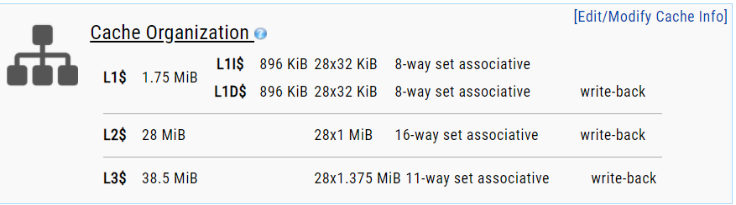

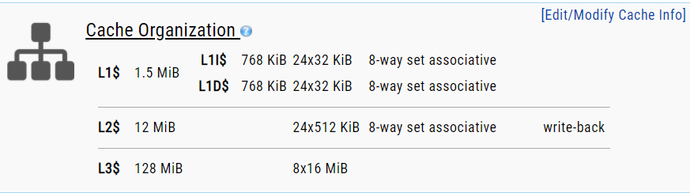

*Memory controller*

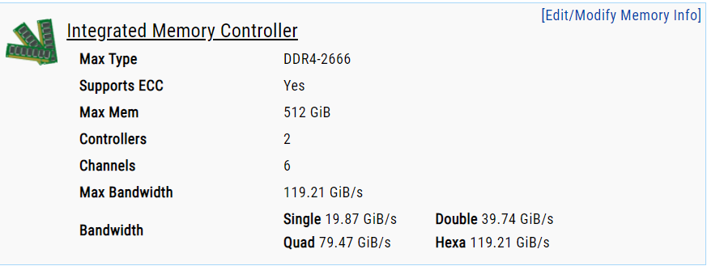

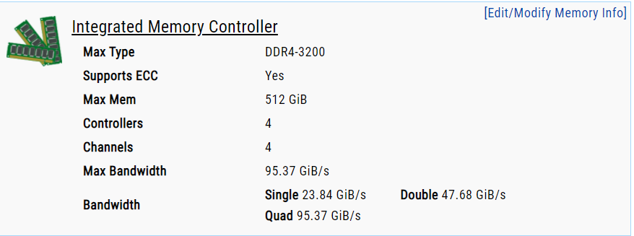

*Expansions*

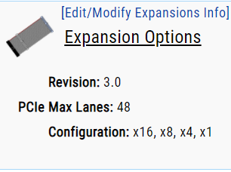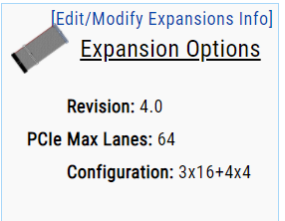

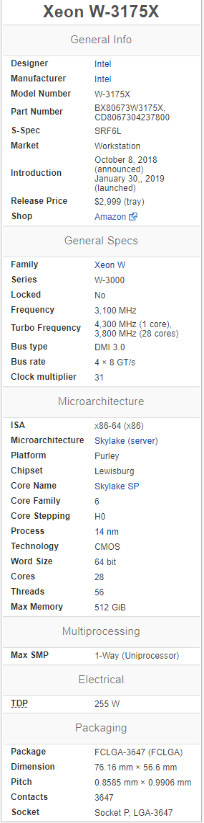 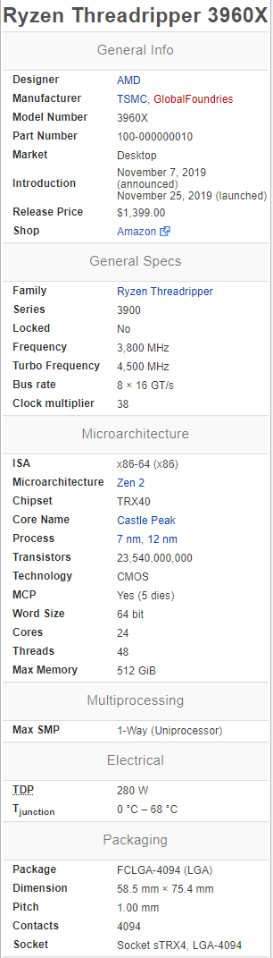

*Conclusions*

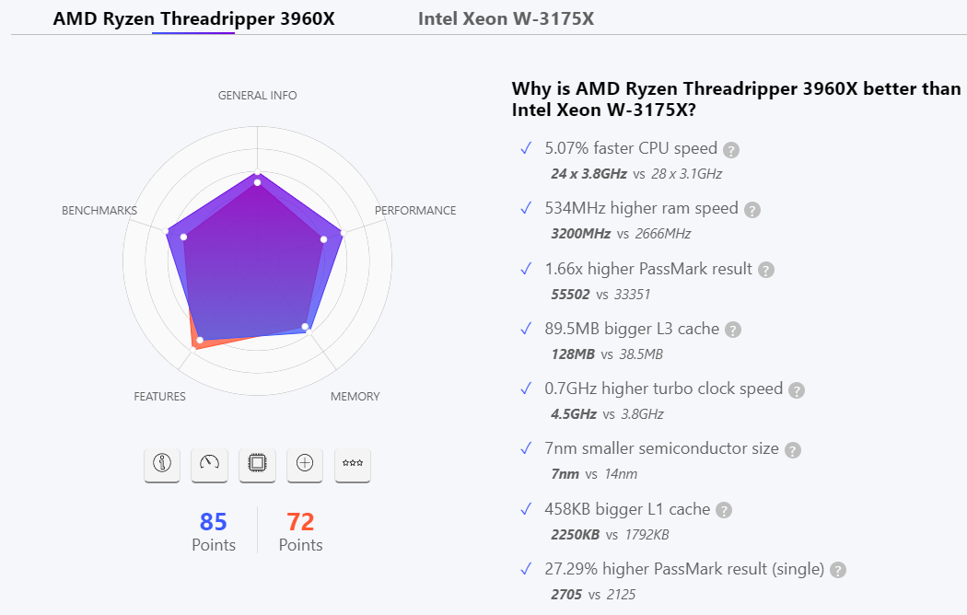

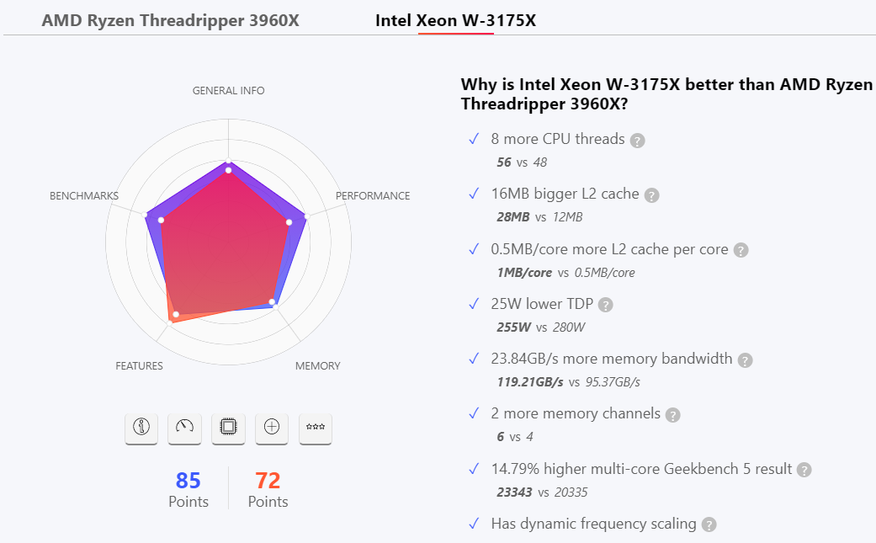

1. **Benchmark Performance**

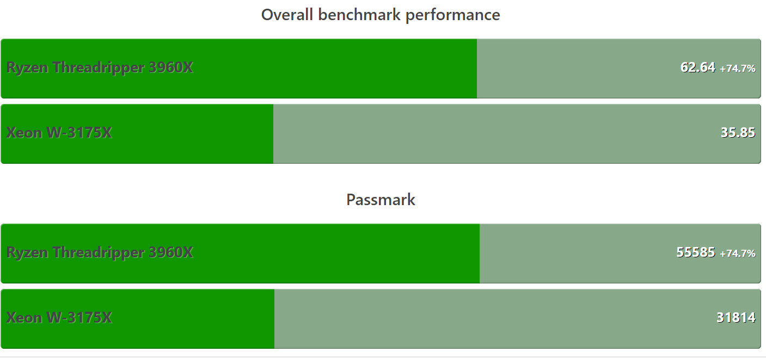

1. **Block diagrams**

*Skylake*

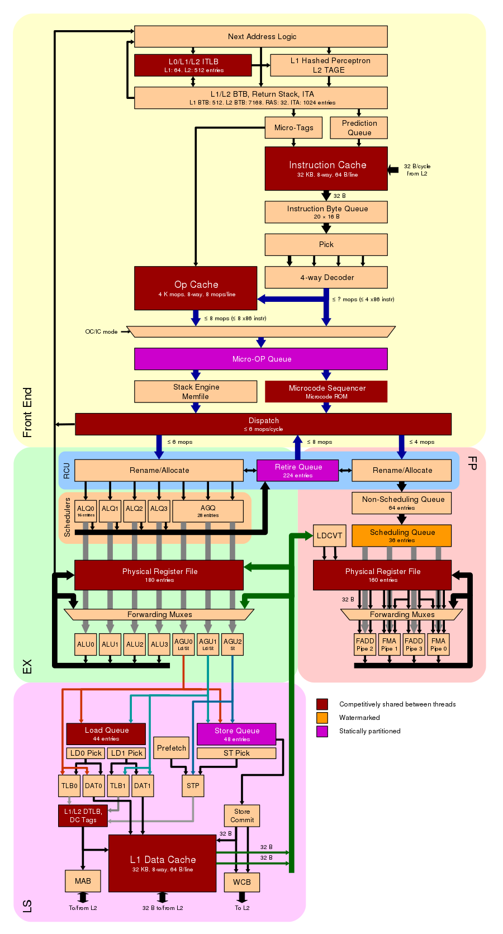

*Zen 2*

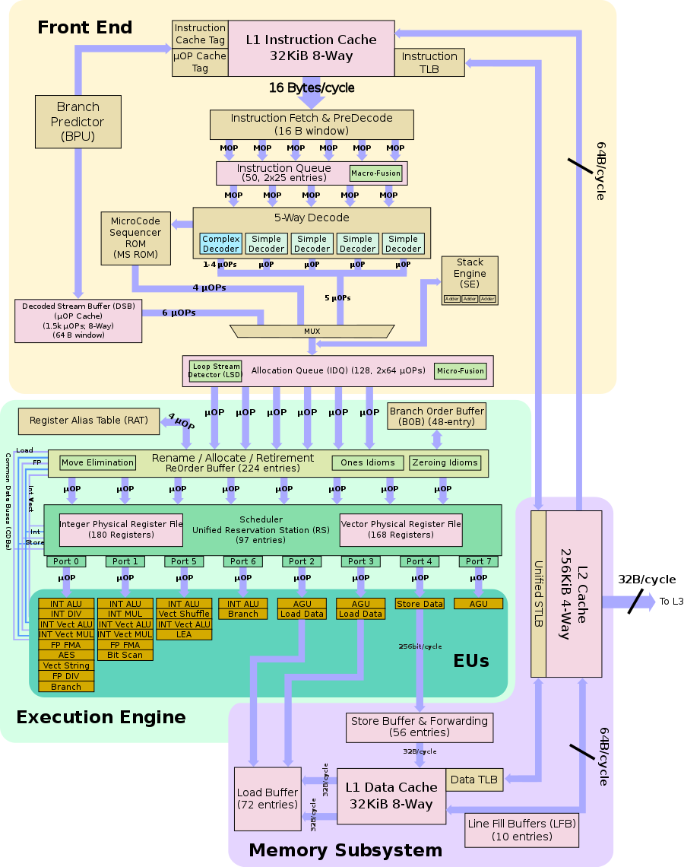

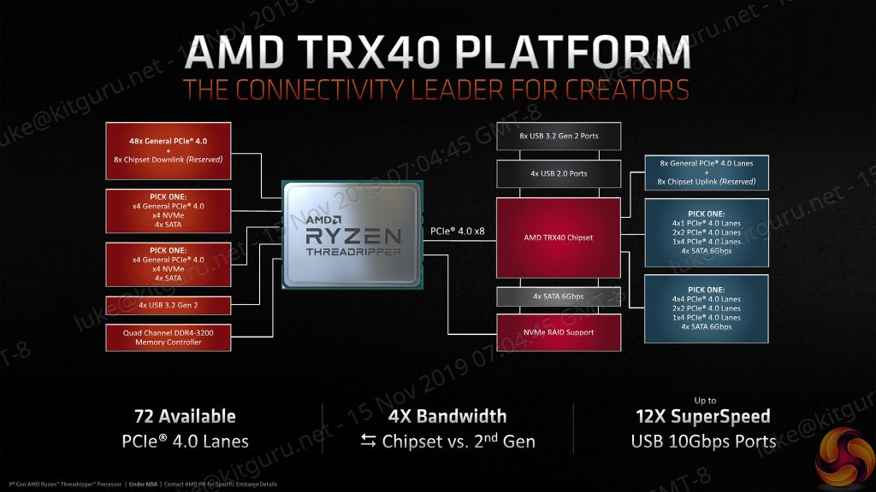

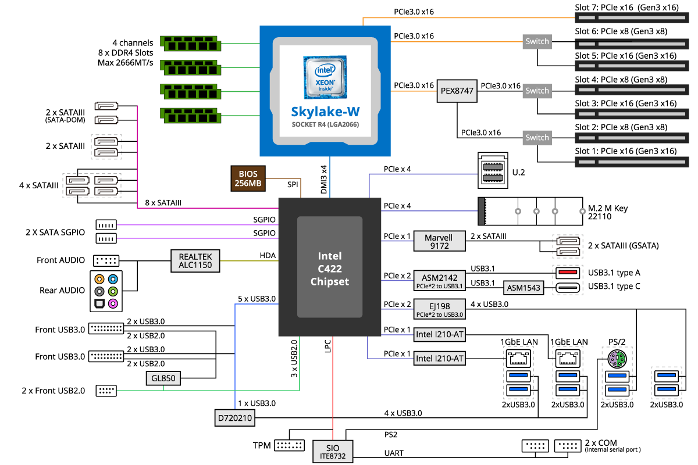

1. **Conclusion**

That was how the AMD Threadripper Third generation processors compare against the Intel Xeon W 3175X. It goes without saying that the AMD siblings do have a few strong points that make it a better proposition when you compare it to the Intel Xeon processor. We assume the comparison above should have provided you a good enough idea into how effective it can be.

Only saving grace, perhaps for the Intel Xeon W 3175X, is that it does not need a motherboard refresh and can work with the existing motherboards. The AMD third gen Threadripper processors would require you to opt for the new TRX40 motherboards, and none of the current motherboards standards are compatible with the 3960X and 3970X (or even the upcoming 3990X).

1. **Bibliography**

* [**https://en.wikichip.org/wiki/amd/microarchitectures/zen**](https://en.wikichip.org/wiki/amd/microarchitectures/zen)
* [**https://en.wikichip.org/wiki/amd/ryzen_threadripper/3960x**](https://en.wikichip.org/wiki/amd/ryzen_threadripper/3960x)
* [**https://en.wikichip.org/wiki/intel/xeon_w/w-3175x**](https://en.wikichip.org/wiki/intel/xeon_w/w-3175x)
* [**https://versus.com/en/amd-ryzen-threadripper-3960x-vs-intel-xeon-w-3175x**](https://versus.com/en/amd-ryzen-threadripper-3960x-vs-intel-xeon-w-3175x)

**RISC vs RISC**

*(Exynos 1080 vs Snapdragon 888)*

1. **Description**

The **Exynos 1080’s** integrated modem adds new levels of speed to downloading content, allowing you to stream and load faster, with minimal latency and lag. The processor is compatible with both types of 5G networks, mmWave and sub-6GHz, enabling downlink speeds of up to 5.1Gbps on the latter.1 Plus, with support for both Bluetooth® 5.2 and Wi-Fi 6, the Exynos 1080 ensures that you’re always connected.

The Qualcomm® **Snapdragon™ 888** 5G Mobile Platform packs industry-leading innovations in 5G, AI, gaming, photography, and the many more premium experiences you deserve. Featuring our completely re-architected 6th gen Qualcomm® Artificial Intelligence (AI) Engine, the Snapdragon 888 5G delivers a total of 26 TOPS performance, 3 times performance-per-watt improvement and 16 times larger shared AI memory.

1. **Specifications**

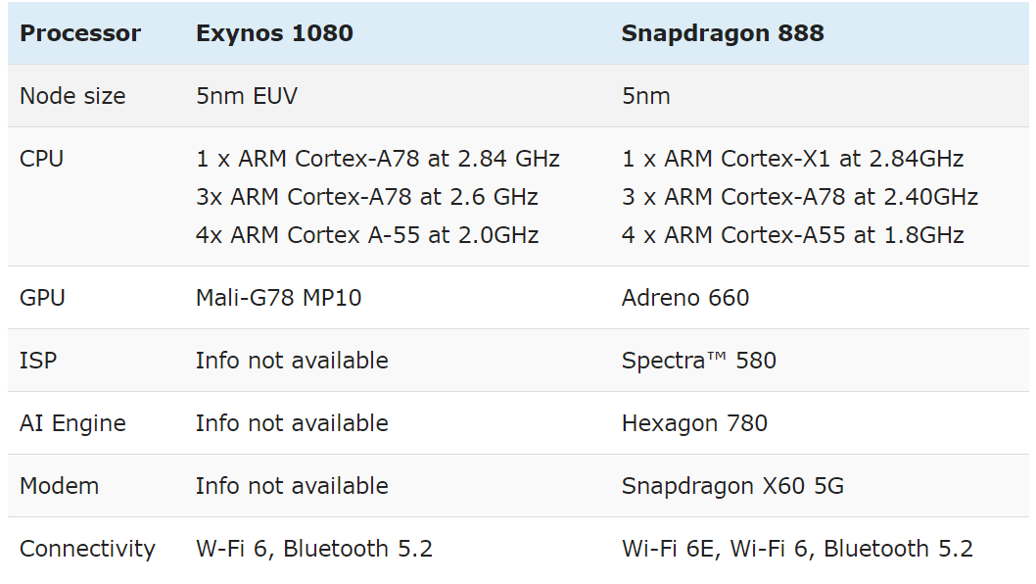

1. **Block Diagram**

*Snapdragon 888*

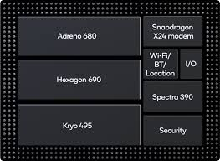

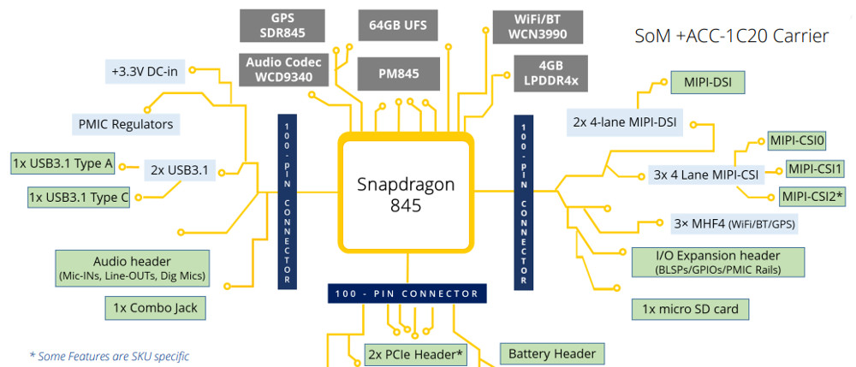

*Exynos 1080*

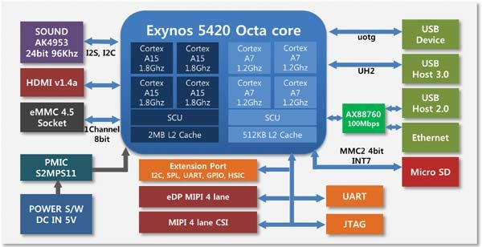

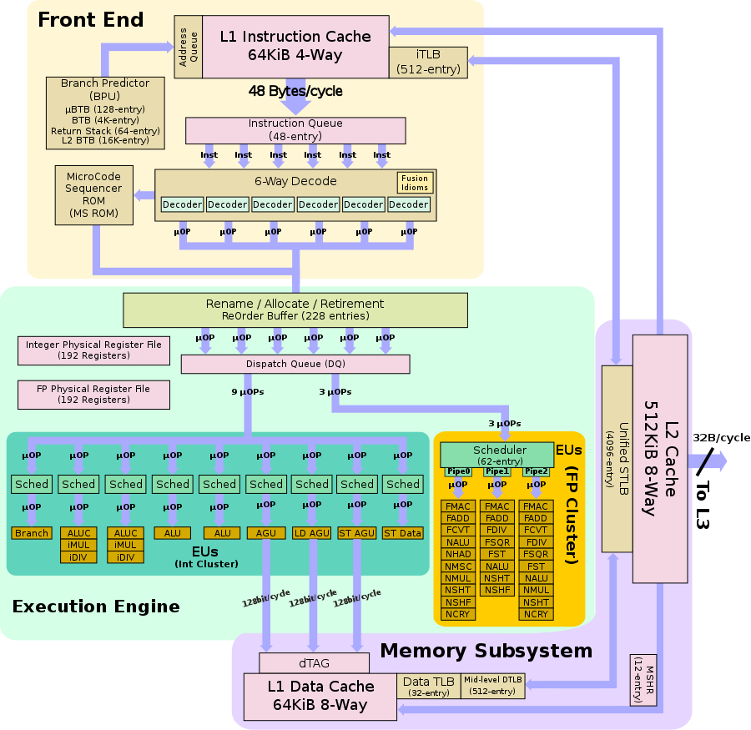

1. **Benchmark**

Exynos 1080 vs Snapdragon 865



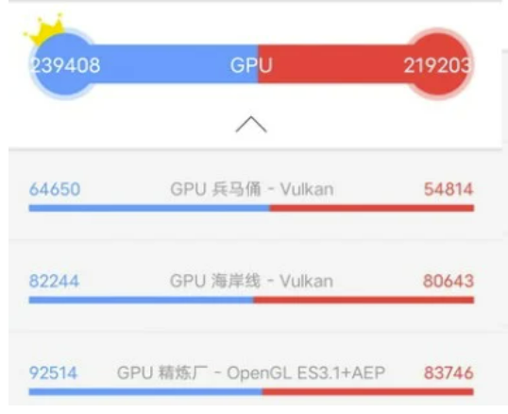

Snapdragon 888

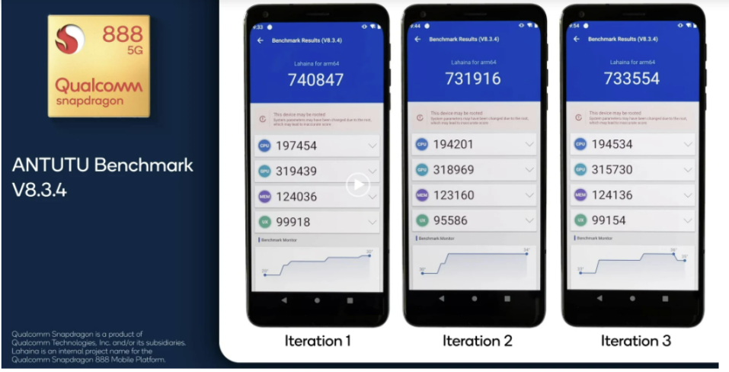

1. **Conclusion**

Snapdragon 888 is the clear winner, as it outperforms CPU and GPU performance. However, the Exynos 1080 is also an excellent chipset, as it almost holds up against Snapdragon 865 in processor performance and even surpasses it in GPU performance. However, its stronger brother, the Exynos 2100, will be the one to challenge the Snapdragon 888.

1. **Bibliography**

* <https://www.gizmochina.com/2021/01/06/chip-battle-how-does-the-exynos-1080-compare-to-the-snapdragon-888/#:~:text=The%20Exynos%201080%20not%20only,Cortex%2DA78%20core%20than%20it.&text=However%2C%20the%20Snapdragon%20888%20has,core%20clocked%20at%202.84GHz>.